**Experiment 1.3**

**Student Name: Rahul Kumar UID: 20BCS7081**

**Branch: BE-CSE Section/Group:20BCS_DM-716 B**

**Semester: 6 Date of Performance: 06/03/23**

**Subject Name: IOT LAB Subject Code: 20CSP_358**

## Aim:

Demonstration of Autodesk Tinkercad Simulation Platform.

## Objective:

* Learn about IoT based simulations.
* Testing and model in IoT based simulation platform.

## Code-Output:

* Hardware Requirement
  + Arduino Uno
  + Ultrasonic

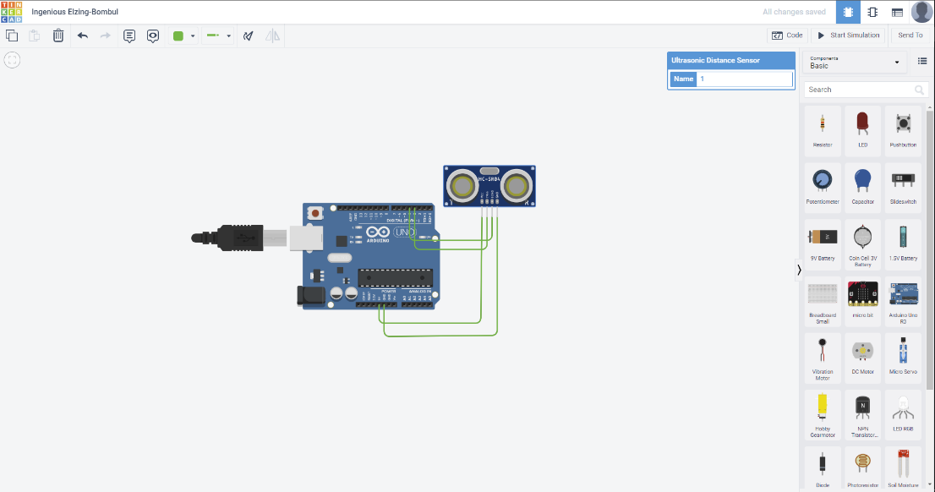

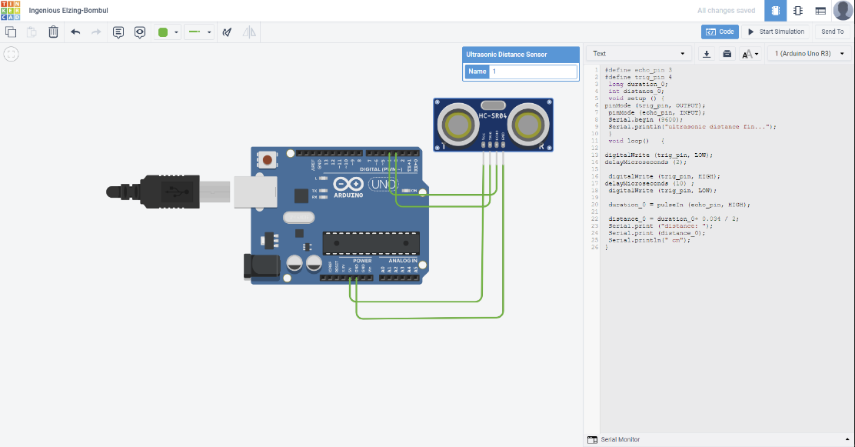

**#define echo_pin 3**

**#define trig_pin 4**

**long duration_0;**

**int distance_0;**

**void setup () {**

**pinMode (trig_pin, OUTPUT);**

**pinMode (echo_pin, INPUT);**

**Serial.begin (9600);**

**Serial.println("ultrasonic distance fin...");**

**}**

**void loop() {**

**digitalWrite (trig_pin, LOW);**

**delayMicroseconds (2);**

**digitalWrite (trig_pin, HIGH);**

**delayMicroseconds (10) ;**

**digitalWrite (trig_pin, LOW);**

**duration_0 = pulseIn (echo_pin, HIGH);**

**distance_0 = duration_0+ 0.034 / 2;**

**Serial.print ("distance: ");**

**Serial.print (distance_0);**

**Serial.println(" cm"); }**

**OUTPUT : -**

